**Industrial Internship Report on**

**Smart streetlight IOT device**

**Prepared by**

**kalidindi vinayakaphani saivarma**

|  |
| --- |
| *Executive Summary* |
| This report provides details of the Industrial Internship provided by upskill Campus and The IoT Academy in collaboration with Industrial Partner UniConverge Technologies Pvt Ltd (UCT).  This internship was focused on a project/problem statement provided by UCT. We had to finish the project including the report in 6 weeks’ time.  My project was: -app to monitor the status of the streetlights remotely and manage them efficiently  This internship gave me a very good opportunity to get exposure to Industrial problems and design/implement solution for that. It was an overall great experience to have this internship. |

**TABLE OF CONTENTS**

1 Preface 3

2 Introduction 4

2.1 About UniConverge Technologies Pvt Ltd 4

2.2 About upskill Campus 8

2.3 Objective 9

2.4 Reference 9

2.5 Glossary 10

3 Problem Statement 11

4 Existing and Proposed solution 12

5 Proposed Design/ Model 13

5.1 High Level Diagram (if applicable) 13

5.2 Low Level Diagram (if applicable) 13

5.3 Interfaces (if applicable) 13

6 Performance Test 14

6.1 Test Plan/ Test Cases 14

6.2 Test Procedure 14

6.3 Performance Outcome 14

7 My learnings 15

8 Future work scope 16

# Preface

## Summary of the whole 6 weeks’ work:

The main aim of this project is to create street light monitoring system android application which involves combination of various technologies such as Android app development, IOT devices, communication protocols and main part is to monitor the status of streetlights with android app and manage them without bugs or errors

### The steps involved for creating the application are:

1. knowing the hardware and its setup:

The main important thing is to know the which hardware is suitable for controlling the streetlights. The IOT devices such as sensors and microcontrollers are used as hardware devices. these devices should have capable of detecting the streetlights whether they are on or off.

Install these IOT devices on each streetlight . The IOT devices used in these project are Ultra sensors and Arduino microcontroller

2. server setup:

Servers should be installed in such a way that it collects and store the data from the Iot devices . It should handle the Incoming data from the LED of lights and store them in the database.

3. App development in android:

The main part of this project is developing the app development. it should contain the following features

a. app should be glitch free

b. it should work when we use near the sensors

4.Data Retrieval:

The app can retrieve all the data like displaying time to time updates .

5. Status display:

Status display is compulsory for an app to make sure that the lights are on or off. I made app interface to display the status of light(ON/OFF).

6. Testing and deployment:

To make a perfect app the app should be bug free. While testing ensure that the communication between app, sever and IOT devices are seamless and perfect

After completion of testing. deploy the application in any app store

Why need of this project in real-life?

There are many advantages of making this application:

* It is safe compared to using switch because switch may give electric shock during rainy days
* Easy maintenance
* Energy conservation
* Improves public safety

How program was planned

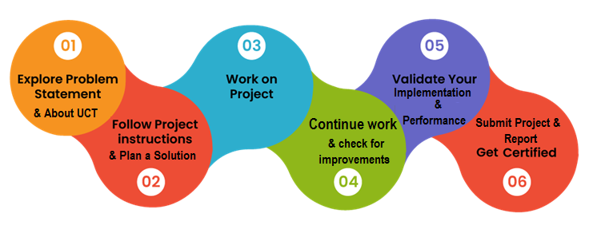

overall experience: -

It was great opportunity for me as android app development. thankyou UPSKILL CAMPUS and UNICONVERGE TECHNOLOGIES(UCT) for giving me this opportunity to create innovative mobile application

Thanks to all members of upskill campus (to my mentor ankit Kumar sir and Santosh sir) who helped me in clarifying the doubts.

Dear juniors and peers,

I would like to share my experience with you regarding full stack development (app development) internship. This was my first internship, initially I am in confusion that how to complete my internship because I don’t have prior experience. but it ended up by gaining my skills from basics. During the internship, I gained practical knowledge which is essential for today tech industries and collaborated with experienced mentors.

I highly recommend all of you to pursue this internship. It will be a great experience which provides solid foundation to your career. stay strong, stay curious never stop learning.

Best wishes,

Kalidindi vinayakaphani saivarma

# 2 Introduction

## About UniConverge Technologies Pvt Ltd

A company established in 2013 and working in Digital Transformation domain and providing Industrial solutions with prime focus on sustainability and RoI.

For developing its products and solutions it is leveraging various**Cutting Edge Technologies e.g. Internet of Things (IoT), Cyber Security, Cloud computing (AWS, Azure), Machine Learning, Communication Technologies (4G/5G/LoRaWAN), Java Full Stack, Python, Front end**etc.

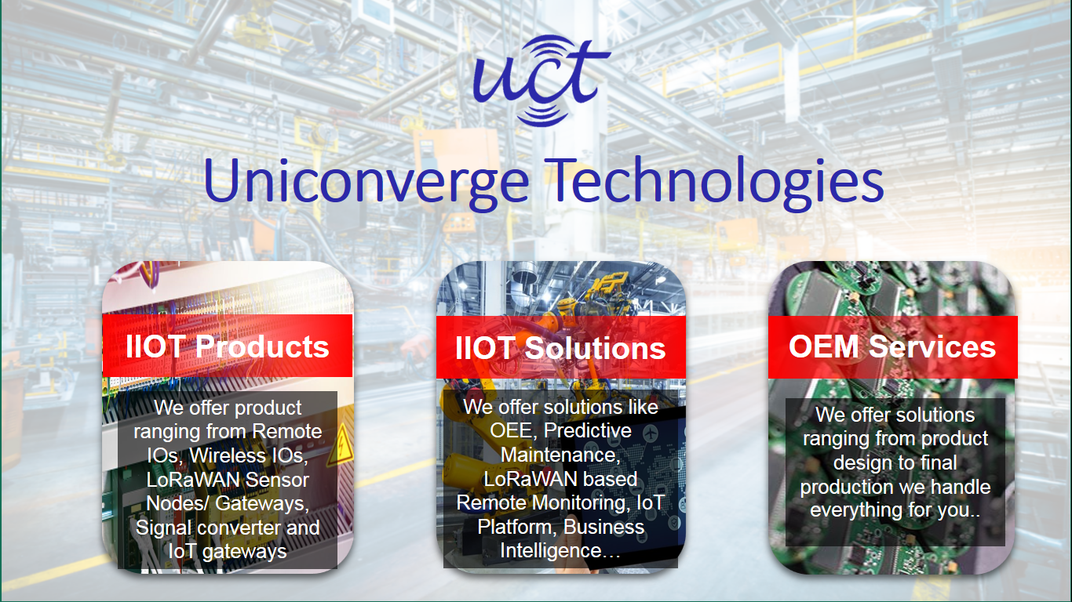

1. UCT IoT Platform **(****)**

**UCT Insight** is an IOT platform designed for quick deployment of IOT applications on the same time providing valuable “insight” for your process/business. It has been built in Java for backend and ReactJS for Front end. It has support for MySQL and various NoSql Databases.

* It enables device connectivity via industry standard IoT protocols - MQTT, CoAP, HTTP, Modbus TCP, OPC UA
* It supports both cloud and on-premises deployments.

It has features to  
• Build Your own dashboard  
• Analytics and Reporting  
• Alert and Notification  
• Integration with third party application(Power BI, SAP, ERP)  
• Rule Engine





1. **Smart Factory Platform (****)**

Factory watch is a platform for smart factory needs.

It provides Users/ Factory

* with a scalable solution for their Production and asset monitoring
* OEE and predictive maintenance solution scaling up to digital twin for your assets.
* to unleased the true potential of the data that their machines are generating and helps to identify the KPIs and also improve them.
* A modular architecture that allows users to choose the service that they what to start and then can scale to more complex solutions as per their demands.

Its unique SaaS model helps users to save time, cost and money.

 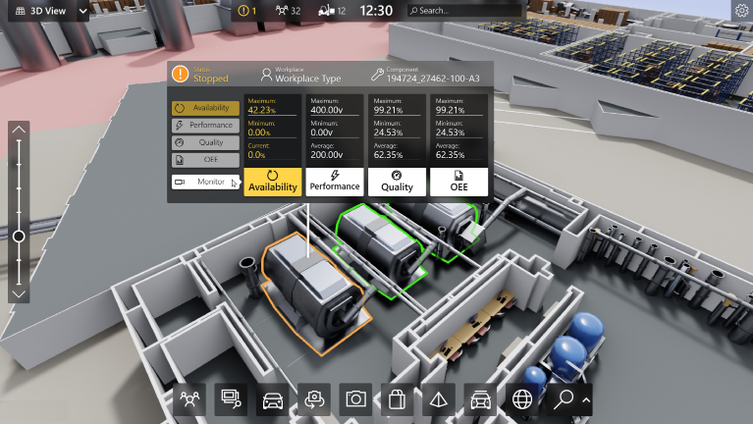

1. 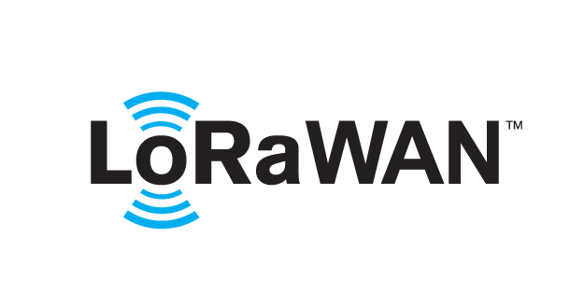 based Solution

UCT is one of the early adopters of LoRAWAN technology and providing solution in Agritech, Smart cities, Industrial Monitoring, Smart Street Light, Smart Water/ Gas/ Electricity metering solutions etc.

1. Predictive Maintenance

UCT is providing Industrial Machine health monitoring and Predictive maintenance solution leveraging Embedded system, Industrial IoT and Machine Learning Technologies by finding Remaining useful life time of various Machines used in production process.



## About upskill Campus (USC)

upskill Campus along with The IoT Academy and in association with Uniconverge technologies has facilitated the smooth execution of the complete internship process.

USC is a career development platform that delivers **personalized executive coaching** in a more affordable, scalable and measurable way.



Seeing need of upskilling in self paced manner along-with additional support services e.g. Internship, projects, interaction with Industry experts, Career growth Services

<https://www.upskillcampus.com/>

upSkill Campus aiming to upskill 1 million learners in next 5 year

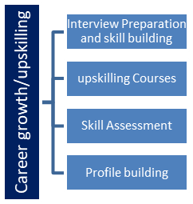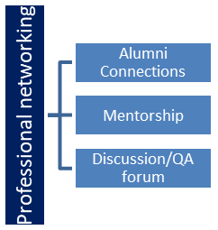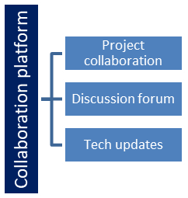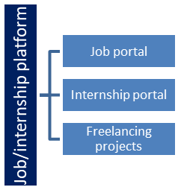

## The IoT Academy

The IoT academy is EdTech Division of UCT that is running long executive certification programs in collaboration with EICT Academy, IITK, IITR and IITG in multiple domains.

## Objectives of this Internship program

The objective for this internship program was to

 ☛ get practical experience of working in the industry.

 ☛ to solve real world problems.

 ☛ to have improved job prospects.

 ☛ to have Improved understanding of our field and its applications.

 ☛ to have Personal growth like better communication and problem solving.

## 1.6 Reference

[1] <https://developer.android.com/studio>

[2] <https://www.upskillcampus.com/>

[3] <https://www.geeksforgeeks.org/>

## 1.7 Glossary

|  |  |
| --- | --- |
| Terms | Acronym |
| UCT | Uniconverge technologies |
| IOT | Internet of things |
| EICT | Electronics and Information communication Technology |
| IITK | Indian Institute of Technology Kanpur |
| IITR | Indian Institute of Technology Roorkee |
| IITG | Indian Institute of Technology Guwahati |

# Problem Statement

In the assigned problem statement

The problem statement mentions a “street light monitoring system with a distance sensor. this system is likely to design to monitor and control the street light

It should consists of:

* Light adjustment control
* Sensors
* On or off controls

**Develop a project related to the street light monitoring system in form of android application**

**Existing and Proposed solution**

To develop a project of smart street light IOT device, you will need to :

* Choose an IOT platform. we used aws IOT
* Design a system architecture
* Develop a hardware
* Implement MQTT and LORAWAN
* Develop app
* Deploy the app

##### Required functionalities:

1. provide users with ability to control the street light in a variety of ways. Light on or off

2. allow users to view data from the sensors

# Software required

The software used in building project are:

* Front end: swift, java, flutter
* Back end: Node Js, java
* Database: cloud based database
* API: IOT device APIs

Limitations of project:

* App may or may not work during natural calamities
* May not work when internet connectivity is low
* Sensors should be protected

1.1 Code submission (Github link) : <https://github.com/Varm0907/upskillcampus-.git>

1.2 Report submission (Github link):

<https://github.com/Varm0907/upskillcampus-.git>

## 3.1 Proposed Design/ Model

1. street light monitoring system: this refers to the overall system that monitors and controls the street lights.

2. distance sensor: the sensors could be utilized to detect vehicles, pedestrians or any other objects

## 3.2High Level Diagram (if applicable)

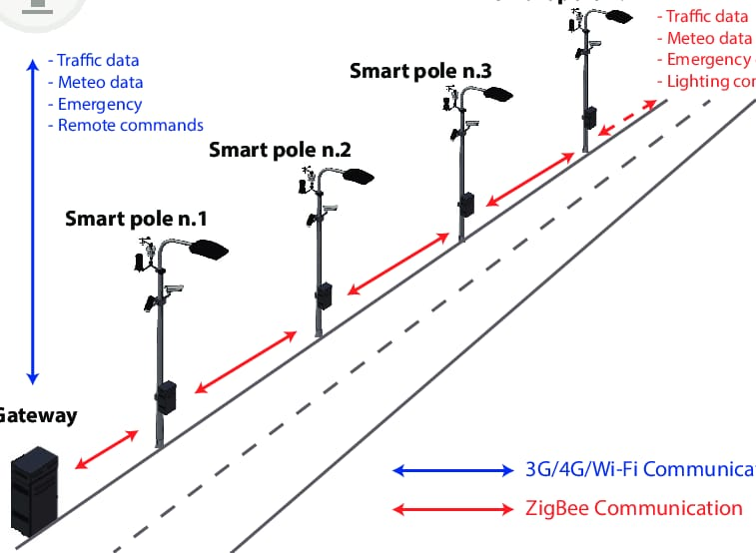

## Figure 1: HIGH LEVEL DIAGRAM OF THE SYSTEM

## 3.3 Low Level Diagram (if applicable)

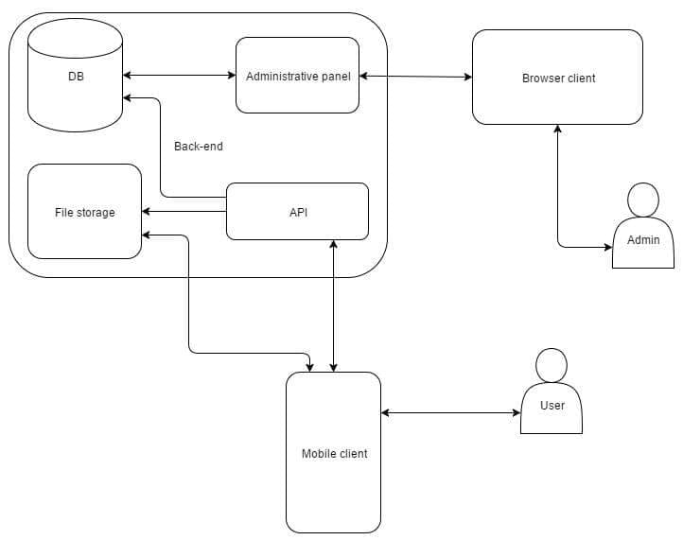

## Interfaces (if applicable)

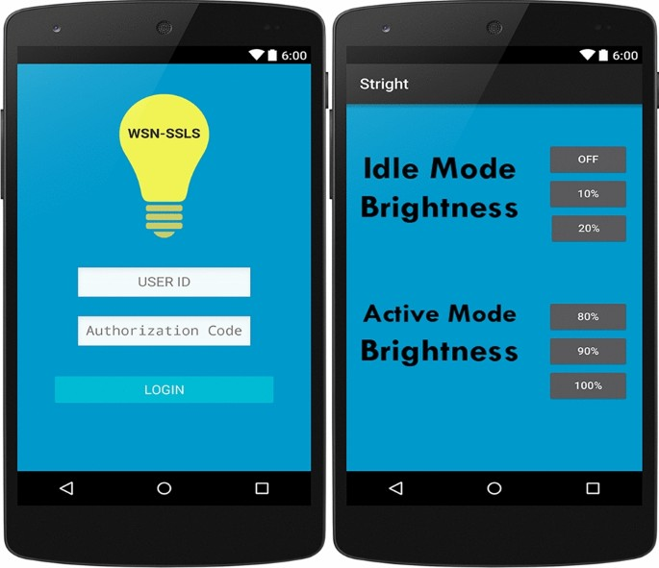

# Performance Test

The performance test is more important after releasing the app

If there is any problem we can change the code accordingly

## There are many softwares where performance test can be done like:

* NEOLOAD
* Apache JMeter

## Performance Outcome

The accuracy of app is 91.2%. app works within 5 seconds after clicking on on/off button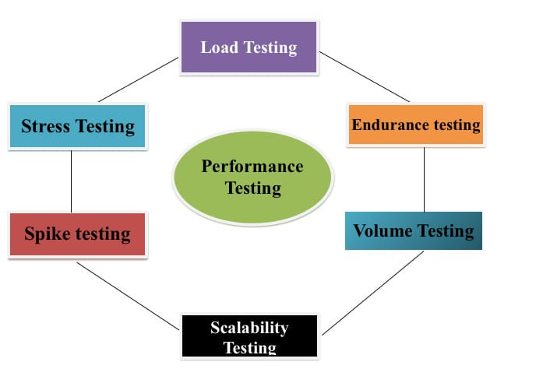

# 5. MY learnings

I have learnt many things from “street light monitoring systems”

* IOT applications
* Energy efficiency
* Automation and controls
* Safety and public services
* Environmental impact
* Real world applications
* Challenges like accuracy, data interpretation

# Future work scope

This project may inspire further developments and improvements in street lighting system . (finalreportholder)

Overall this project is perfect example for how technology can harnessed without environmental damage (sustainability)